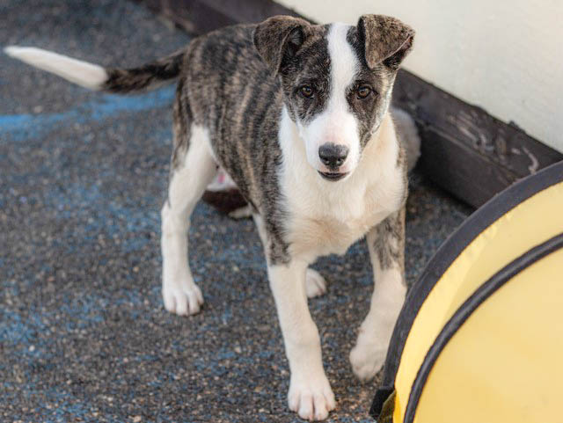
FREE!

RABIES VACCINE & MICROCHIP
DRIVE-THRU CLINIC FOR DOGS AND CATS

with attending veterinarian Cathy Gatlin, DVM

Saturday, June 5th 2021
9:00 am to Noon
Calaveras County Government Center
891 Mountain Ranch Road, San Andreas
- Open to Calaveras County Residents Only
- All dogs must be on leash
- All cats must be in carriers

Did you know?
All dogs 4 months and older are required to be vaccinated for Rabies and licensed in Calaveras County

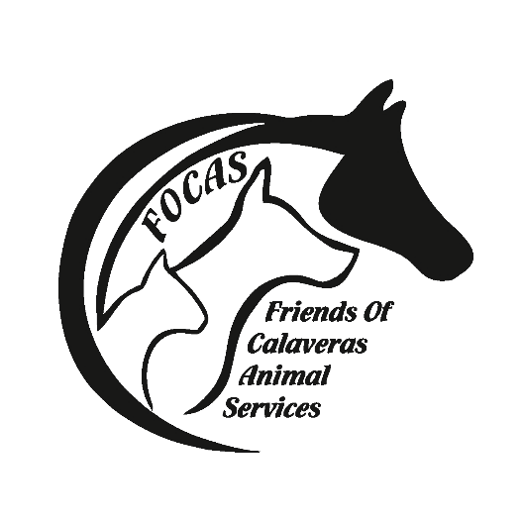

Presented by Friends of Calaveras Animal Services
501c3 non-profit supported by community donations
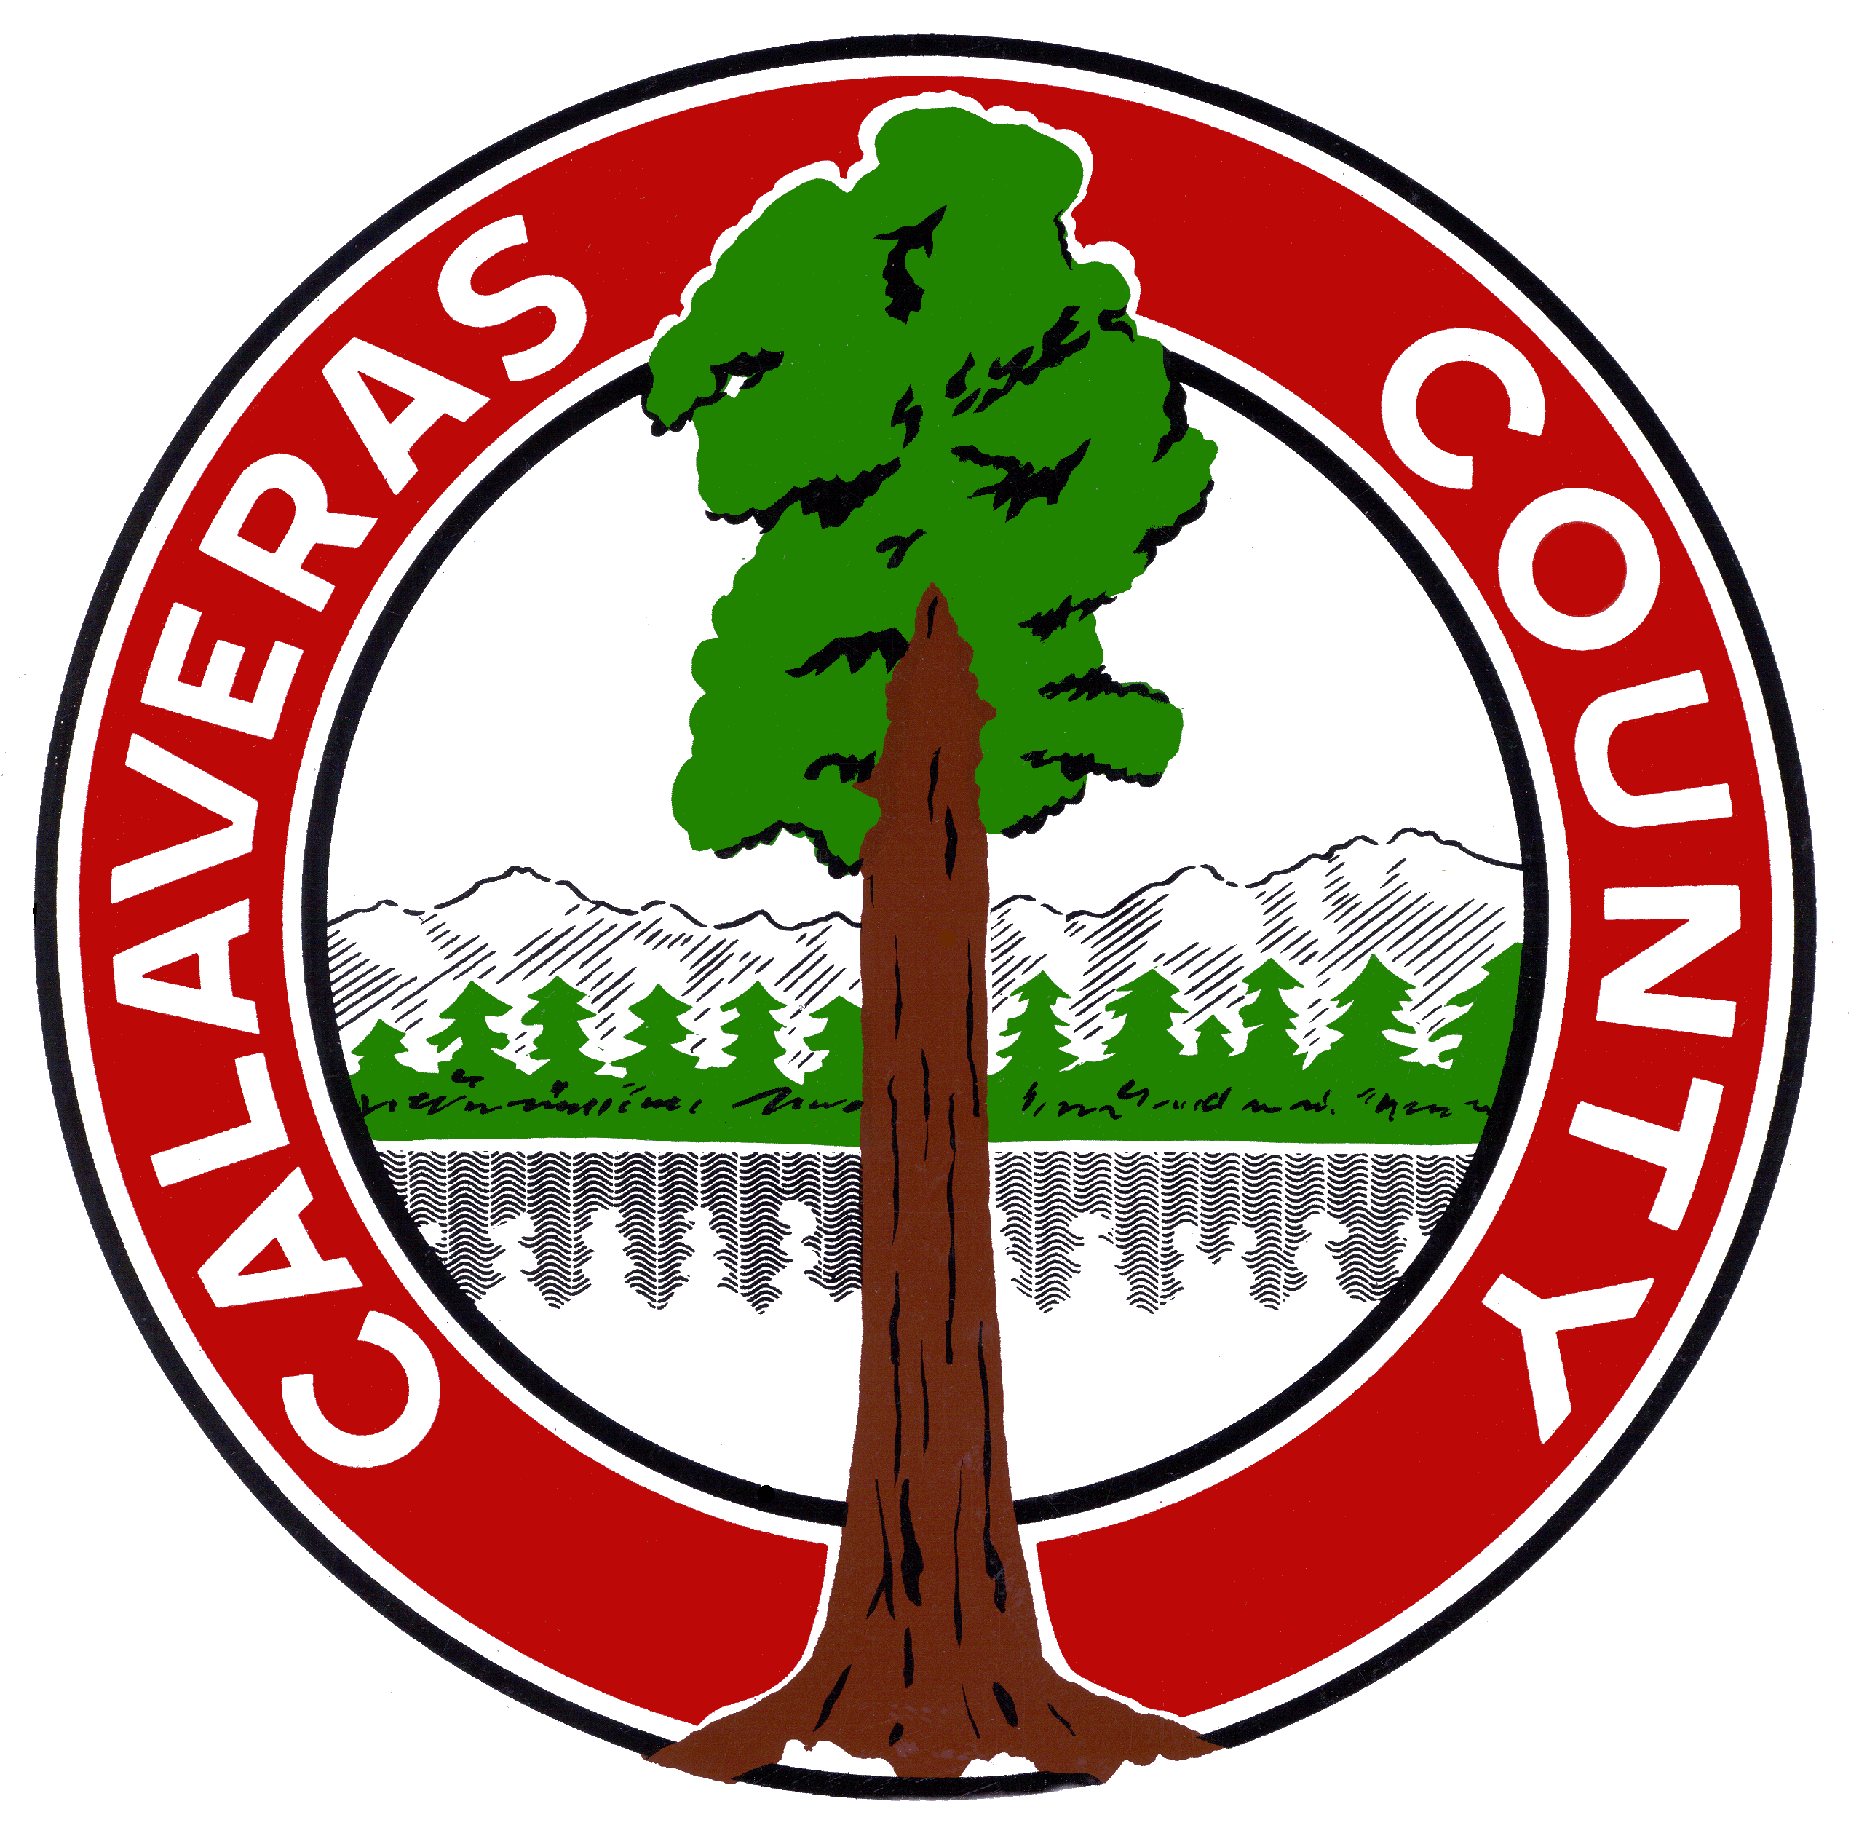
Questions? (209) 754-6509
Calaveras County Animal Services

